## **Agenda: Getting Starting with Microsoft Azure**

* Introduction to Azure
* Azure Hosting Models
* Azure Services
* Subscribing to Microsoft Azure
* Azure Portals
* Azure Resource Group

**Microsoft Azure Introduction**

* **Microsoft Azure** (formerly called as **Windows Azure** prior to 3rd April 2014) falls primarily under the category of the **PaaS** service model of cloud computing, freeing the developer from having to worry about things like managing networks, purchasing hardware and provisioning servers.
* **What is Azure**
  + It is a comprehensive **suite** of cloud products that allow users to create **enterprise-class applications** without having to build their **own infrastructure**.
  + Azure is an **OS** for the data center of Microsoft Cloud.
    - Handles resource management, provisioning and monitoring.
    - Manages application lifecycle.
    - Allows developers to concentrate on business logic.
* **Why Azure**
  + Has qualities of a well architected application:
    - Reliability
    - Availability
    - Maintainability
  + Microsoft Azure allows for immediate provisioning and de-provisioning – pay only for what you use.
  + One can quickly ***Scale******up (vertical scaling)*** and ***Scale******out (horizontal scaling)*,** also *back down* when load subsides.
  + Has **Autoscaling** Capabilities based on CPU usage percentage and Recurring Schedule.
  + Load balancing is built-in.
  + Leveraging existing investments in virtualization. Hybrid approach doesn’t require long term commitment or investment.
  + Provides Geo-redundancy.
  + Microsoft has already invested in redundancy, failover, caching, storage, authorization etc. and we can leverage it inexpensively.
* **What Azure Provides** 
  + It enables you to quickly create, build, deploy and manage **web applications and services** across a **global network** of Microsoft datacenters.
  + Common building blocks for distributed applications.
  + Reliable queuing, simple structured and unstructured storage.
  + Application services like access control, caching, connectivity
  + etc.
* **Facts about Azure Data Centers:**
  + <https://www.youtube.com/watch?v=0ie_741exNs>
  + Azure is available in 150 countries including 60 regions and supports 17 languages and 24 currencies, all backed by Microsoft's **$15 billion** (USD) investment in global datacenter infrastructure.
  + Geos = US, Europe, Asia Pacific, Middle East and Africa
  + Region = Contains one or more data centers and are split into zones.

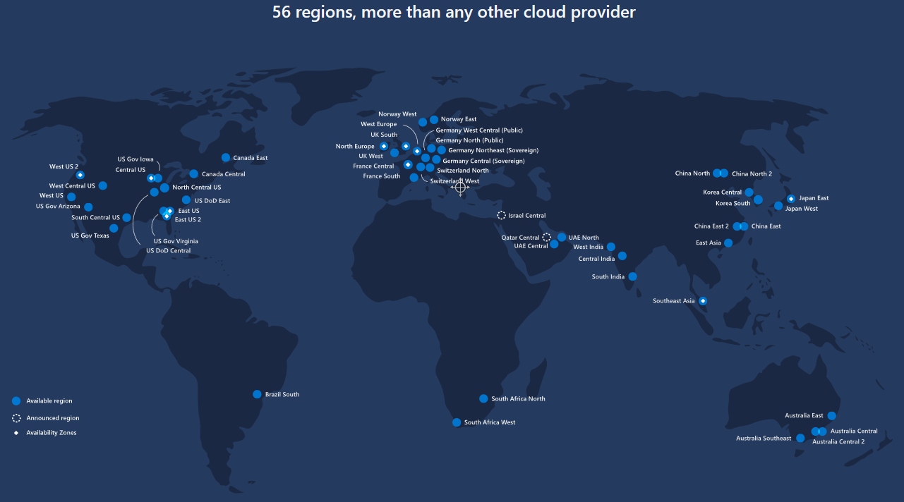

**Region Pairing:**

<https://docs.microsoft.com/en-us/azure/best-practices-availability-paired-regions>

**Globe:**

<https://infrastructuremap.microsoft.com/explore>

**A list of regions and their locations is available at https://azure.microsoft.com/en-us/global-infrastructure/locations/**

* A region represents a collection of datacenters.
* Provides flexibility and scale.
* Preserves data residency.
* Select regions close to your users.
* Be aware of region deployment availability.
* There are global services that are region independent.

A full list of region pairs is available at <https://docs.microsoft.com/en-us/azure/best-practices-availability-paired-regions#what-are-paired-regions>

* Each Azure region is paired with another region.
* Azure prefers at least 300 miles (483 Kms) of separation between datacenters in a regional pair.
* Some services provide automatic replication to the paired region.
* In an outage, recovery of one region is prioritized out of every pair.
* Azure system updates are rolled out to paired regions sequentially (not at the same time).
* Paired regions are members of the same geography – except Brazil.

**Availability Zones**

* Availability Zones are a high-availability solution provided by Microsoft Azure that enable customers to run their applications and services in multiple data center locations within a region.
* Availability Zones are physically separate data centers within an Azure region, each with their own power, cooling, and networking infrastructure.

* Availability Zones are **unique physical locations** within an Azure region.
* Each zone is made up of one or more datacenters equipped with **independent power, cooling, and networking**.
* To ensure resiliency, there’s a minimum of **three separate zones** in all **enabled regions**.
* The **physical separation** of Availability Zones within a region protects applications and data from **datacenter failures**.
* **Zone-redundant** services replicate your applications and data across Availability Zones to protect from **single-points-of-failure**.
* With Availability Zones, Azure offers industry best 99.99% VM uptime SLA.
* An **Availability Zone** in an Azure region is a **combination of a fault domain and an update domain**. So, if you’re deploying a web tier consisting of 2 VMs in Ireland, you can now make sure that VM1 is placed in Availability Zone 1 and VM2 is placed in Availability Zone 2. If zone 1 was to fail, you (and your customers) would still be able to access VM2 in AZ2.
* This means your service **won’t** have to run from a **separate Azure region** and will be faster as a result. This is especially useful if your customers are concentrated in a single region.
* Availability Zones are also ideal if you must obey **regulatory requirements and laws** that require your data/services to be highly available inside a single Azure Region.

Build high-availability into your application architecture by co-locating your compute, storage, networking, and data resources within a zone and replicating in other zones.

Azure services that support Availability Zones fall into two categories:

* **Zonal services** – you pin the resource to a specific zone (for example, virtual machines, managed disks, Standard SKU IP addresses)
* **Zone-redundant services (ZRS)** – platform replicates automatically across zones (for example, zone-redundant storage, SQL Database, Standard SKU IP addresses).



* **Benefits of Azure**
  + Developers don’t have to create VMs or use Remote Desktop (RDP) to log into each one and install the application. They just hit a button (or pretty close to it), and the tools provided by Microsoft **provision** the VMs and then deploy and install the application on them.
  + Azure provides the flexibility to quickly set up development and test configurations. These can be scripted, giving you the ability to **spin up** a development or test environment, do the testing, and spin it back down. **This keeps the cost very low, and maintenance is almost nonexistent.**
  + New architectural options for developing High Performance, Scalable, redundantly available, reliable applications for all – **small and large** organizations.
  + In addition to **MS.NET**, it also supports languages such as **Java, Ruby, Node.js, PHP, Python, Go, Typescript, Scala** and standard internet protocols such as HTTP, HTTPS, TCP etc.

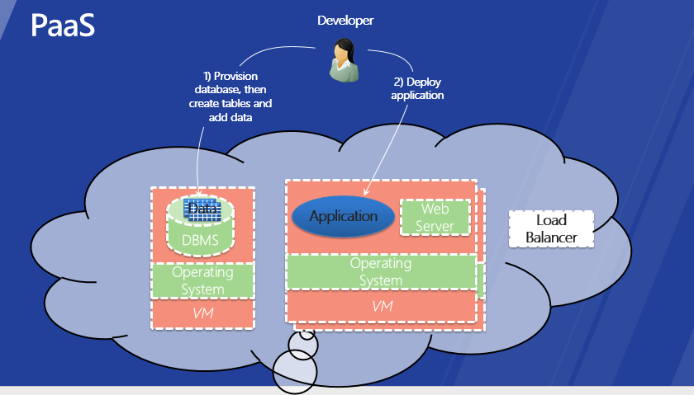

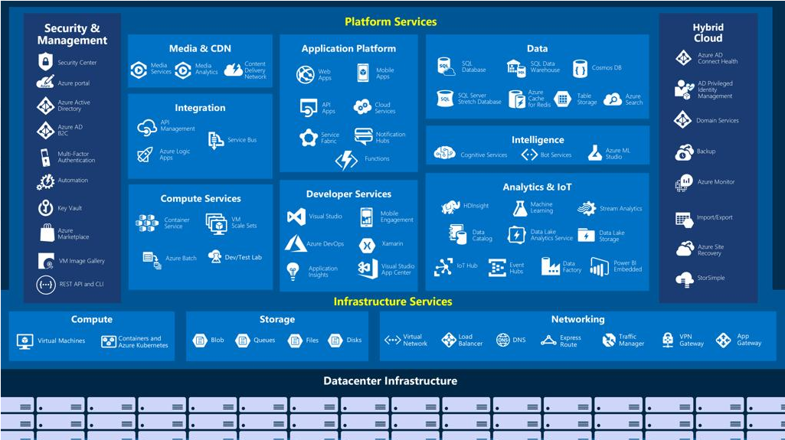

**Azure Hosting Models**

Azure includes many services in its cloud computing platform. Let’s talk about a few of them.

Azure provides different hosting models for running applications. Each one provides a different set of services, so which one you choose depends on exactly what you're trying to do.

1. **Virtual Machines (IaaS)**
2. **~~Cloud Services (outdated)~~**
3. **App Services (PaaS)**
4. **Azure Container Instances**
5. **Kubernetes Service (AKS) or Service Fabric (ASF)**
6. **Azure Batch Service**

**Virtual Machines:**

* With support for Linux, Windows Server, Oracle, IBM and SAP, Azure Virtual Machines gives you the flexibility of virtualisation for a wide range of computing solutions—development and testing, running applications, and extending your datacenter.
* Azure Virtual Machine enables you to create a **server in the cloud** that you can control and manage, customize the VHD settings of the VM, create multiple VMs and load balance traffic between them.
* Combine the performance of a world-class supercomputer with the scalability of the cloud. Scale from one to thousands of virtual machine instances. Plus, with the growing number of regional Azure datacenters, easily scale globally so you are closer to where your customers are.

**~~Cloud Services~~**~~:~~

* ~~It is Microsoft’s Platform as a Service (PaaS) environment used to create scalable, reliable and low admin applications and services. The applications are built with roles. A role represents a single component built with managed code, which runs in the Azure environment in a virtual machine (instance).~~
* ~~Support not only web based deployments, but also multi-tier architectures where you might have a combination of front ends, middle tiers, as well as virtual machines running as part of your solution.~~
* ~~Supports automated application management, so it is really easy to deploy, scale out, isolate, and recover from any type of hardware failure.~~

**App Services**

* Azure App Service is the only cloud PAAS service that integrates everything you need to **quickly and easily** build web and mobile apps for **any platform and any device**.
* App Service allows you to host the following app types:
  1. **Web Apps**: Create and deploy mission-critical web apps that scale with your business. Supports .NET, Java, PHP, Node.js, and Python.
  2. **API Apps:** API Apps lets you take your new and existing APIs and automatically generate SDKs for a variety of languages, including C#, Java, JavaScript, and more—empowering your business to easily use your APIs for web, mobile, and desktop applications.
  3. **Logic Apps:** The Logic Apps feature of Azure App Service helps keep your marketing and analytics SaaS apps in sync. Extend business processes in minutes. Boost sales productivity by reducing data entry.
  4. **Azure Functions:** These are serverless functions with no dedicated hardware.

**Note**: Virtual Machines, App Services and Cloud Services can be used separately or combine more than one to create an application.

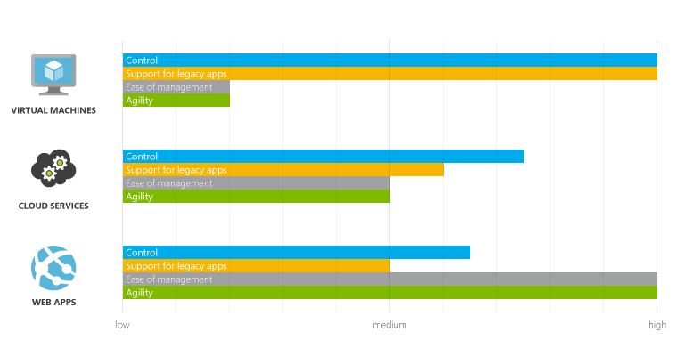

**Azure Database Services**

**SQL Database Service**

* SQL Database is a Database-as-a-Service (DaaS) offering that makes SQL databases accessible for cloud developers.
* Developers do not have to install setup or manage any database.
* It also has full support for TSQL programming language, programmability support through managed ADO.NET access, Native ODBC, PHP as well as JDBC.
* There are many tools available for migration of databases as well as data to and from SQL Server and SQL Database.

**Storage Service**

* Azure Storage is massively scalable, durable and highly available so you can store and process **hundreds** **of terabytes of data** to support the big data scenarios required by scientific, financial analysis, and media applications. Or you can store **the small amounts** of data required for a small business website.
* Azure Storage also provides the storage foundation for Azure Virtual Machines.
* Azure Storage currently stores **tens of trillions** of unique customer objects, and handles millions of requests per second on average.
* A storage account gives you access to the Azure storage data services:

1. Blob storage
2. Table storage
3. Queue storage
4. File storage

**CosmosDB Service**

Azure CosmosDB is a **NoSQL** document database service designed from the ground up to natively support JSON and JavaScript directly inside the database engine. It is the right solution for applications that run in the cloud when **predictable throughput, low latency** and flexible query are key

3vs = Variety, Velocity and Volume.

**Azure Network Services**

**Virtual Networks**

* An Azure virtual network (VNet) is a representation of your own network in the cloud. It is a **logical isolation** of the Azure cloud dedicated to your subscription.
* You can fully control the IP address blocks, DNS settings, security policies and route tables within this network.
* You can also further segment your VNet into **subnets** and launch Azure IaaS virtual machines (VMs) and/or Cloud services (PaaS role instances).
* **In essence, you can expand your network to Azure, with complete control on IP address blocks with the benefit of enterprise scale Azure provides.**

**Content Delivery Network**

It is a service to deliver high bandwidth content. For example if you enable CDN access for a storage account, in which you use a BLOB, it is stored at a location which is closer to the user and thus improves the performance by using maximum bandwidth.

**Azure Traffic Manager**

**Azure ExpressRoute**

**Azure Application Services**

* One of the other things we do with Azure to enable that is provide a bunch of Application Building Blocks. These are managed services that we run to provide a lot of value so you can avoid setting up the infrastructure for common capabilities.
* You can provision VMs and put anything you want in it but in a lot of cases you will find that we have **built-in services** that are delivered by Microsoft and their partners. What’s cool is that you can use any of these services with a VM, with a Web App, or with a Cloud Service – so you have flexibility in how you will consume them.

**Some Important Services:**

* **Media Service:** Azure Media Services powers consumer and enterprise streaming solutions worldwide. Combining powerful and highly scalable cloud-based encoding, encryption and streaming components, Media Services helps customers with valuable and premium video content easily reach larger audiences on today’s most popular digital devices, such as tablets and mobile phones
* **Service Bus:** Azure Service Bus is a generic, cloud-based messaging system for connecting just about anything—applications, services and devices—wherever they are. Connect apps running on Azure, on-premises systems, or both. You can even use Service Bus to connect household appliances, sensors and other devices like tablets or phones to a central application or to each other.
* **Search Service:** Azure Search makes it easy to add powerful and sophisticated search capabilities to your website or application. The integrated Microsoft natural language stack, also used in Bing and Office, has been improved over 16 years of development.
* **Business Analytics** – It allows you to easily build reporting capabilities into your Azure application. SQL Azure Reporting provides many of the features you know from SQL Server Reporting to create reports with tables, charts, maps etc. and more and deploy them on both private and public clouds. Reports can be exported to popular file formats such as Excel, Word, PDF, XML etc. You can use Business Intelligence Design Studio and Sql Server Tools to deploy your reports onto the cloud reporting server.
* **HD Insight** – It is the Apache Hadoop based Service for Azure that lets you analyze data so big that relational databases can't handle.
* **Caching** – It provides distributed in memory cache service for Azure and SQL database applications.
* **Access Control** – It is a service that allows makes it easier for an application to accept identity information from Facebook, Google, Windows Live ID, and other popular identity providers. Rather than requiring the application to understand the diverse data formats and protocols used by each of these providers, Access Control translates all of them into a single common format.
* **Azure AD Graph** provides programmatic access to read data in Azure Active Directory (AD) through REST API endpoints.
* **Azure Authentication Library (AAL)** makes it very easy for developers to add to their client applications the logic for authenticating users to Azure Active Directory or their providers of choice, and obtain access tokens for securing API calls.
* **and Many more…**

**Azure Portals**

The management portal of Azure is an interface to configure and control Azure services and applications (Storage, Virtual Machines, SQL Database, Virtual Network etc…).

Azure Portal: <https://portal.azure.com/>

## 

## **Journey and Blades**

## The portal is organized as journeys. A journey is a series of blades, which are containers for the different components.

* The components within the blades are called parts, which look like tiles.

The new portal contains the following user interface elements:

* **Dashboard**: The home page for your Azure environment. You can pin commonly used items to the dashboard to make it easier to navigate to them. By default, the dashboard includes tiles that show the global Azure service health, a shortcut to the Azure gallery of available services, and a summary of billing information for your subscriptions.
* **Blades**. Panes in which you can view and configure the details of a selected item. Each blade displays as a pane in the user interface, often containing a list of services or other items that you can click to open other blades. New blades open to the right side. In this way, you can navigate through several blades to view the details of a specific item in your Azure environment. You can maximize and minimize some blades to optimize the screen space and simplify navigation.
* **Hub menu**. A bar on the left side of the page, which contains the following icons:
  + Home: Returns the page to the left side so that the Hub menu and dashboard are visible.
  + Notifications: Opens a blade on which you can view notifications about the status of tasks.
  + Browse: Starts a journey to view the details of a service in your Azure environment.
  + Billing: Provides details about charges and the remaining credit for your subscriptions. Billing is also available on a resource group basis.
  + New: Creates a new service in your Azure environment.

**Note**: You can also use **Windows PowerShell** and **Azure CLI** (Command Line Interface) to manage your Azure environment. Visual Studio also provides lots of Tools for managing Azure Resources and Creating and publishing Websites.

**Forecast cost with the pricing calculator:**

The pricing for each service in Azure is different. Many Azure services provide Basic, Standard, and Premium tiers. Usually, each tier has several price and performance levels. By using the online pricing calculator (<https://azure.microsoft.com/en-us/pricing/calculator/>), you can create pricing estimates. The calculator includes flexibility to estimate cost on a single resource or a group of resources.

**Subscribing to Microsoft Azure**

1. **Free trial:** This gives you a $200 credit and a month to try out any combination of resources in Azure. Visit <https://azure.microsoft.com/en-us/free/>
2. **Visual Studio Subscriptions:** If you have an MSDN subscription, you get a specific amount in Azure credit each month. For example, if you have a Visual Studio Premium with MSDN subscription, you get $150 per month in Azure credit.
3. **Pay-as-you-go:** With this subscription, you pay for what you use by attaching a credit card or debit card to the account. If you are an organization, you also can be approved for invoicing.
4. **Enterprise agreements:** With an enterprise agreement, you commit to using a certain amount of services in Azure over the next year, and you pay that amount ahead of time.

**Managing Account Subscriptions Portal:**

From Azure Portal you can view and edit your subscription, including usage statistics and billing details. You can also edit your profile.

To open the subscriptions page: Portal 🡪 Account name 🡪 View my bill. It will navigate you to <https://account.windowsazure.com/Subscriptions>

The following options are available on the subscriptions page:

• Change payment method

• Download usage details

• Contact Microsoft support

• Edit subscription details

• Change subscription address

• View partner information

• Cancel your subscription

**Azure Key Concepts**

**Resources:** Azure resources are individual compute, networking, data, or app hosting services that have been deployed into an Azure subscription. Some common resources are a virtual machines, storage accounts, or SQL databases. Azure services often consist of several related Azure resources. For instance, an Azure virtual machine might include a VM, storage account, network adapter, and public IP address. All of these are individual resources. Each resource can be created, managed, and deleted individually or as a group. Azure resources are covered in more detail later in this guide**.**

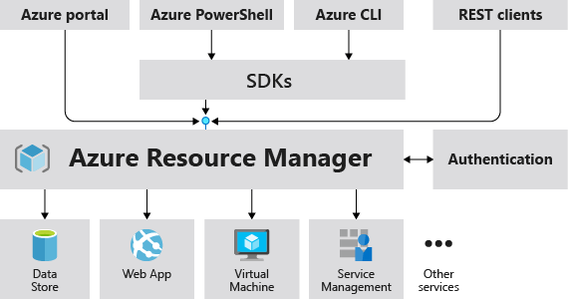

**Azure Resource Manager (ARM) Templates:** An Azure Resource Manager template is a JavaScript Object Notation (JSON) file that defines one or more resources to deploy to a resource group. It also defines the dependencies between deployed resources. Resource Manager templates are covered in more detail later in this guide.

**Automation**: In addition to creating, managing, and deleting resources by using the Azure portal, you can automate these activities by using PowerShell or the Azure command-line interface (CLI).

**Azure PowerShell**: Azure PowerShell is a set of modules that provide cmdlets to manage Azure. You can use the cmdlets to create, manage, and remove Azure services. In most cases, you can use the cmdlets for the same tasks that you perform in the Azure portal. The cmdlets can help you can achieve consistent, repeatable, and hands-off deployments. For more information, see How to install and configure Azure PowerShell.

**Azure command-line interface**: The Azure command-line interface is a tool that you can use to create, manage, and remove Azure resources from the command line. The Azure CLI is available for Linux, Mac OS X, and Windows. For more information and technical details, see Install the Azure CLI.

**REST APIs** Azure is built on a set of REST APIs that support the Azure portal UI. Most of these REST APIs are also supported to let you programmatically provision and manage your Azure resources and apps from any Internet-enabled device. For more information, see the Azure REST SDK Reference.

**Azure Resource Groups:** A resource group is a container that holds related resources (maybe a virtual machine, storage account, and virtual network, or a web app, database, database server, and 3rd party services) for an application. The resource group could include all of the resources for an application, or only those resources that are logically grouped together.

**There are some important factors to consider when defining your resource group:**

1. All of the resources in your group must share the same lifecycle. You will deploy, update and delete them together. If one resource, such as a database server, needs to exist on a different deployment cycle it should be in another resource group.
2. Each resource can only exist in one resource group.
3. You can add or remove a resource to a resource group at any time.
4. You can move a resource from one resource group to another group.
5. A resource group can contain resources that reside in different regions.
6. A resource group can be used to scope access control for administrative actions.

Management Group

Management Group(s) = (6 Levels down) = Policies(Governance) / RBAC – Role Based Access Control

Subscription(s) = Policies(Governance) / RBAC – Role Based Access Control / Billing Container (Credit Card)

Resource Group(s) = Policies(Governance) / RBAC – Role Based Access Control

Resource(s) = RBAC – Role Based Access Control

Note: Role is a collection of permissions <=> User / Group / Service Principal

